School Council Pumpkin Carving Competition:

- Decorate and design your own pumpkin
- Bring it to school on Friday 28th
- Do your best and you could win a prize
- Prizes for first, second and third places!

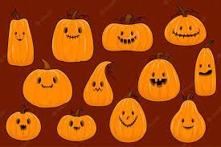

School Council Pumpkin Carving Competition:

- Decorate and design your own pumpkin
- Bring it to school on Friday 28th
- Do your best and you could win a prize
- Prizes for first, second and third places!

