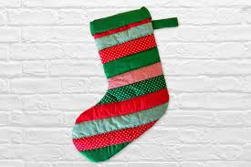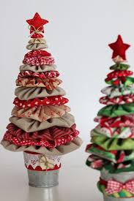

Kingsmills Primary School
Patchwork Classes
We are hoping to restart the patchwork classes in Kingsmills Primary School on Tuesday 5th October 2021 at 7pm.
(All Covid restrictions will be in place)
If you would be interested in making patchwork cushions, throws, quilts or baby quilts.
If further information is required, please contact Heather.
Tele; 07784598384.

