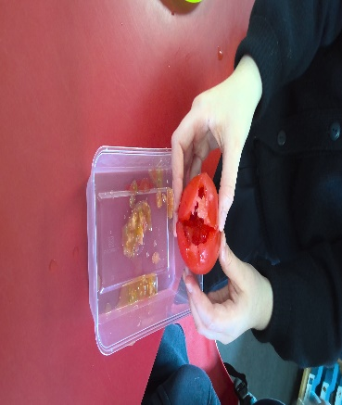
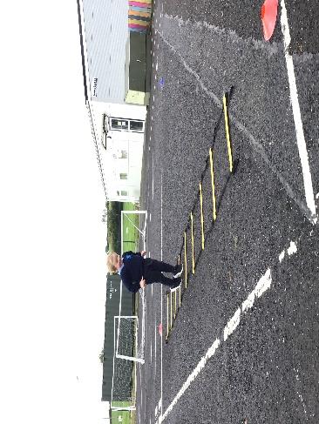
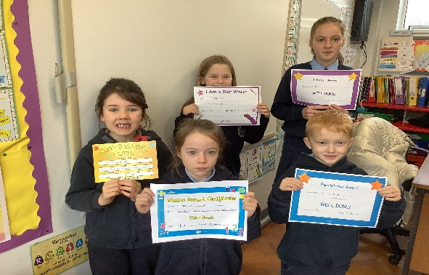
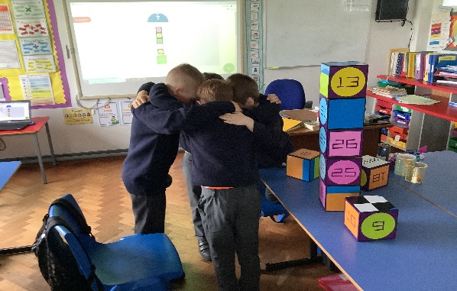
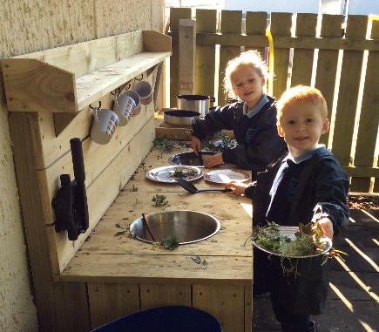
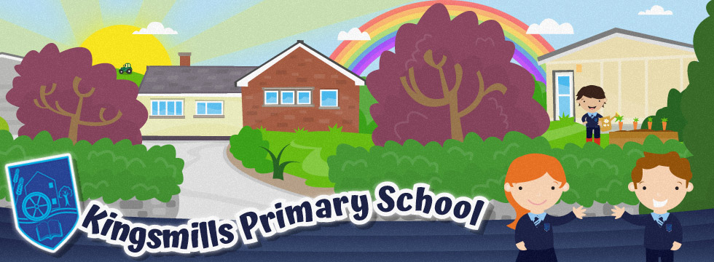
Open
Day

For all Reception and P1 pupils or new pupils wishing to enter P2 - P7
Friday 9th December 2022
Please contact the school office to make an appointment. All visits will be on a 1:1 basis
‘The school promotes a strong sense of inclusion in which every
child is valued’
Education and Training Inspectorate
63 Drumnahunshin Road, Whitecross, Armagh BT60 2TA
028 3083 0312

For further details contact: gharrison869@c2kni.net
www.kingsmillsps.co.uk

